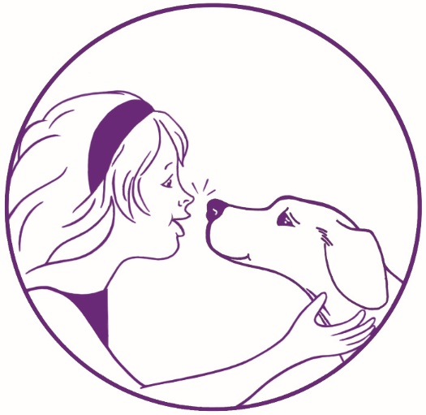
Wet Nose Canine
Carolyn Rancourt
47 Davis Street
Rehoboth, MA 02769
508-241-4826
carolyn@wetnosespa.com

Agility Workshop
With Jeff Botelho!
About Jeff:
- Four time AKC National Finalist!
- 2018 AKC World Team member!
- 2019 AKC EO Team Member!
- Jeff has been doing agility for more than 10 years and utilizes a variety of handling methods.

Day One AM: 6/4/22: Young dogs short sequences – no contacts
Day One PM: 6/4/22: Experienced dogs handling the full course JWW
Day Two AM: 6/5/22: Young dogs short sequences – some contacts (handlers choice)
Day Two PM: 6/5/22: Experienced dogs handling the full course with contacts

$100 for each working session – limited to 8 teams
$50 for each auditing session – limited to 5 auditors

- Lunch, snacks and beverages provided.
- Water hose and doggie pool provided
- Shade will be available for crating
Contact Carolyn at carolyn@wetnosespa.com if you have any questions.
Complete the registration form below and return with payment to secure your enrollment.
No refunds after 5/5/22 (unless cancelled by Jeff). Make checks payable to Wet Nose Canine.

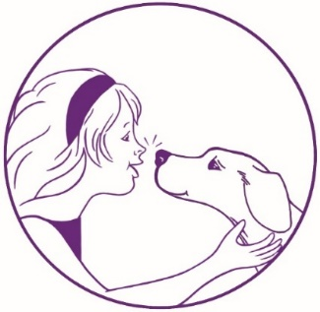
Wet Nose Canine
Carolyn Rancourt
47 Davis Street
Rehoboth, MA 02769
508-241-4826
carolyn@wetnosespa.com
Agility Workshop With Jeff Botelho!

Name: Home Phone:

Address: Daytime Phone:

City: State: Zip: Email:

Dog’s Name: Jump Height: Dog’s DOB: _______ ______

No refunds after 5/5/22. Make checks payable to Wet Nose Canine.

Day One AM: 6/4/22  Young dogs short sequences – no contacts | Working Team ⃣ | Auditor ⃣
Day One PM: 6/4/22  Experienced dogs handling the full course JWW | Working Team ⃣ | Auditor ⃣
Day Two AM: 6/5/22  Young dogs short sequences – some contacts | Working Team ⃣ | Auditor ⃣
Day Two PM: 6/5/22  Experienced dogs handling the full course contacts | Working Team ⃣ | Auditor ⃣

$100 for each working session – limited to 8 teams
$50 for each auditing session – limited to 5 auditors

WAIVER, ASSUMPTION OF RISK, AND AGREEMENT TO INDEMNIFY AND HOLD HARMLESS
I understand attendance in a dog training class is not without risk to myself, members of my family or guests who may attend or to my dog because some dogs to which I (we) will be exposed may be difficult to control and may be the cause of injury even when handled with the utmost care.

I hereby waive and release Wet Nose Canine, owners and agents from any and all liability of any nature for injury or damage which I or my dog may suffer, including specifically, but not without limitation to, any injury or damage resulting from the action of any dog, and I
expressly assume the risk of any such damage or injury while attending any training session or other service of Wet Nose Canine or while on property of 47 Davis Street Rehoboth, MA or the surrounding area.

I hereby agree to indemnify and hold harmless Wet Nose Canine, its employees, owners, and agents from any and all claims, or claims by any member of my family or any other person accompanying me to any training session or service of Wet Nose Canine or while on the grounds or the surrounding area as a result of any action by any dog, including my own.

Signature of owner/s: _______________________________________________________________ Date:___________________
Signature of owner/s: _______________________________________________________________ Date:___________________

Signature of Handler (if not owner): ______________________________________________________ Date:___________________

